Android Content Providers

In Android security model, one application cannot directly access (read/write) other applications data. Every application has its own id data directory and own protected memory area.
Content provider is the best way to share data across applications. Content provider is a set of data wrapped up in a custom API to read and write.
Applications/Processes have to register themselves as a provider of data. Other applications can request Android to read/write that data through a fixed API. Content provider API here to CRUD principle.
Examples for content provider are Contacts-that exposes user information to other applications, Media store-Allows other applications to access, store media files.
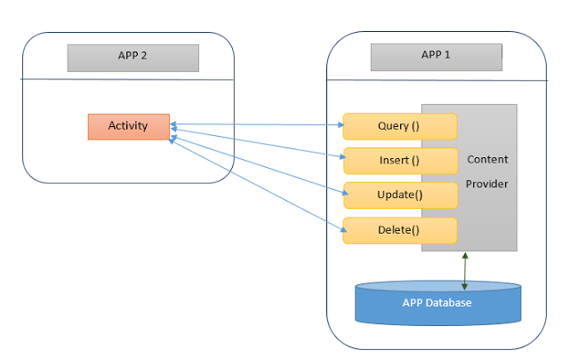

Above diagram shows how content provider works.
App 1 stores its data in its own database and provides a provider.
App 2 communicates with the provider to access App 1's data.
Content providers are simple interfaces which uses standard insert(), query(), update(), delete() methods to access application data. So it is easy to implement a content provider.
A special URI starting with content:// will be assigned to each content providers and that will be recognized across applications.
Writing a content provider:
The ContentProvider class is the central component of a content provider. To create a content provider we have to
1. Create sub class for ContentProvider.
2. Define content URI
3. Implement all the unimplemented methods. insert(), update(), query(), delete(), getType().
4. Declare the content provider in AndroidManifest.xml
Defining URI:
Content provider URI consists of four parts.
content:// authority/path/id
  - content:// All the content provider URIs should start with this value
  - 'authority' is Java namespace of the content provider implementation. (fully qualified Java package name)
  - 'path' is the virtual directory within the provider that identifies the kind of data being requested.
  - 'id' is optional part that specifies the primary key of a record being requested. We can omit this part to request all records.
Adding new records:
We need to override insert() method of the ContentProvider to insert new record to the database via content provider.
The caller method will have to specify the content provider URI and the values to be inserted without the ID. Successful insert operation will return the URI value with the newly inserted ID.
For example: If we insert a new record to the content provider content://com.example/sample the insert method will return content://com.example/sample/1
Updating records:
To update one or more records via content provider we need to specify the content provider URI.
update() method of the ContentProvider is used to update records. We have to specify the ID of the record to update a single record.
To update multiple records, we have to specify 'selection' parameter to indicate which rows are to be changed.
This method will return the number of rows updated.
Deleting records:
Deleting one or more records is similar to update process. We need to specify either ID or 'selection' to delete records.
delete() method of the ContentProvider will return the number of records deleted.
Querying the content provider:
To query the data via content provider we orverride query() method of ContentProvider.
This method has many parameters. We can specify list columns to put into the result cursor using 'projection' parameter. We can specify 'selection' criteria. We can specify 'sortOrder' too.
If we do not specify projection, all the columns will be included in the result cursor. If we do not specify sortOrder the provider will choose its own sort order.
getType() method:
This method is used handle requests for the MIME (Multi-purpose Internet Mail Extensions) type of the data at the given URI.
We use either vnd.android.cursor.item or vnd.android.cursor.dir is used to represent specific item. Another one is used to specify all items.
Registering the provider in AndroidManifest.xml
As with any other major parts of Android application, we have to register the content providers too in the AndroidManifest.xml.
<provider> element is used to register the content providers.
<application> is its parent element.
<provider
android:name=".MyProvider"
android:authorities="com.example.contentproviderexample.MyProvider">
</provider>

1. Application 'MyProvider'
This application will create a content provider and share its data. This uses SQLite database 'mydb'. It has a table called 'names'. The table names have two columns id,name.
The URI of this content provider is content://com.example.contentproviderexample.MyProvider/cte.
We have layout to insert new records to the database table.
XML Snippet
<LinearLayout xmlns:android="http://schemas.android.com/apk/res/android"
android:layout_width="fill_parent"
android:layout_height="fill_parent"
android:orientation="vertical" >
<TextView
android:layout_width="fill_parent"
android:layout_height="wrap_content"
android:text="Name" />
<EditText
android:id="@+id/txtName"
android:layout_width="fill_parent"
android:layout_height="wrap_content" />
<Button
android:id="@+id/btnAdd"
android:layout_width="fill_parent"
android:layout_height="wrap_content"
android:onClick="onClickAddName"
android:text="Add Name" />
</LinearLayout>
Content provider class:
MyProvider.java
public class MyProvider extends ContentProvider
{
static final String PROVIDER_NAME = "com.example.contentproviderexample.MyProvider";
static final String URL = "content://" + PROVIDER_NAME + "/cte";
static final Uri CONTENT_URI = Uri.parse(URL);

static final String id = "id";
static final String name = "name";
static final int uriCode = 1;
static final UriMatcher uriMatcher;
private static HashMap<String, String> values;
static {
uriMatcher = new UriMatcher(UriMatcher.NO_MATCH);
uriMatcher.addURI(PROVIDER_NAME, "cte", uriCode);
uriMatcher.addURI(PROVIDER_NAME, "cte/*", uriCode);
}

@Override
public int delete(Uri uri, String selection, String[] selectionArgs) {
int count = 0;
switch (uriMatcher.match(uri)) {
case uriCode:
count = db.delete(TABLE_NAME, selection, selectionArgs);
break;
default:
throw new IllegalArgumentException("Unknown URI " + uri);
}
getContext().getContentResolver().notifyChange(uri, null);
return count;
}

@Override
public String getType(Uri uri) {
switch (uriMatcher.match(uri)) {
case uriCode:
return "vnd.android.cursor.dir/cte";

default:
throw new IllegalArgumentException("Unsupported URI: " + uri);
}
}

@Override
public Uri insert(Uri uri, ContentValues values)
{
long rowID = db.insert(TABLE_NAME, "", values);
if (rowID > 0) {
Uri _uri = ContentUris.withAppendedId(CONTENT_URI, rowID);
getContext().getContentResolver().notifyChange(_uri, null);
return _uri;
}
throw new SQLException("Failed to add a record into " + uri);
}

@Override
public boolean onCreate() {
Context context = getContext();
DatabaseHelper dbHelper = new DatabaseHelper(context);
db = dbHelper.getWritableDatabase();
if (db != null) {
return true;
}
return false;
}

@Override
public Cursor query(Uri uri, String[] projection, String selection,
String[] selectionArgs, String sortOrder) {
SQLiteQueryBuilder qb = new SQLiteQueryBuilder();
qb.setTables(TABLE_NAME);

switch (uriMatcher.match(uri)) {
case uriCode:
qb.setProjectionMap(values);
break;
default:
throw new IllegalArgumentException("Unknown URI " + uri);
}
if (sortOrder == null || sortOrder == "") {
sortOrder = name;
}
Cursor c = qb.query(db, projection, selection, selectionArgs, null,
null, sortOrder);
c.setNotificationUri(getContext().getContentResolver(), uri);
return c;
}

@Override
public int update(Uri uri, ContentValues values, String selection,
String[] selectionArgs) {
int count = 0;
switch (uriMatcher.match(uri)) {
case uriCode:
count = db.update(TABLE_NAME, values, selection, selectionArgs);
break;
default:
throw new IllegalArgumentException("Unknown URI " + uri);
}
getContext().getContentResolver().notifyChange(uri, null);
return count;
}

private SQLiteDatabase db;
static final String DATABASE_NAME = "mydb";
static final String TABLE_NAME = "names";
static final int DATABASE_VERSION = 1;
static final String CREATE_DB_TABLE = " CREATE TABLE " + TABLE_NAME
+ " (id INTEGER PRIMARY KEY AUTOINCREMENT, "
+ " name TEXT NOT NULL);";

private static class DatabaseHelper extends SQLiteOpenHelper {
DatabaseHelper(Context context) {
super(context, DATABASE_NAME, null, DATABASE_VERSION);
}

@Override
public void onCreate(SQLiteDatabase db) {
db.execSQL(CREATE_DB_TABLE);
}

@Override
public void onUpgrade(SQLiteDatabase db, int oldVersion, int newVersion) {
db.execSQL("DROP TABLE IF EXISTS " + TABLE_NAME);
onCreate(db);
}
}
}
Activity class:
MainActivity.java
public class MainActivity extends Activity
{

@Override
protected void onCreate(Bundle savedInstanceState) {
super.onCreate(savedInstanceState);
setContentView(R.layout.activity_main);
}

@Override
public boolean onCreateOptionsMenu(Menu menu) {
// Inflate the menu; this adds items to the action bar if it is present.
getMenuInflater().inflate(R.menu.activity_main, menu);
return true;
}

public void onClickAddName(View view) {
ContentValues values = new ContentValues();
values.put(MyProvider.name, ((EditText) findViewById(R.id.txtName))
.getText().toString());
Uri uri = getContentResolver().insert(MyProvider.CONTENT_URI, values);
Toast.makeText(getBaseContext(), "New record inserted", Toast.LENGTH_LONG)
.show();
}
}
AndroidManifest.xml
<provider
android:name=".MyProvider"
android:authorities="com.example.contentproviderexample.MyProvider"
android:exported="true"
android:multiprocess="true" >
</provider>
Output
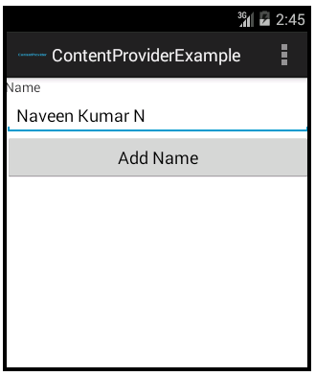

2. Application 'MyUser'
This application will use the query() method to access the data stored in the 'MyProvider' application. This application is having a layout to display the data.

XML Snippet

<LinearLayout xmlns:android="http://schemas.android.com/apk/res/android"
android:layout_width="fill_parent"
android:layout_height="fill_parent"
android:orientation="vertical" >
<Button
android:id="@+id/btnRetrieve"
android:layout_width="fill_parent"
android:layout_height="wrap_content"
android:onClick="onClickDisplayNames"
android:text="Display names" />
<TextView
android:id="@+id/res"
android:layout_width="match_parent"
android:layout_height="wrap_content"
android:layout_marginLeft="20dp"
android:clickable="false"
android:ems="10" >
</TextView>
</LinearLayout>
Activity class:
MainActivity.java
We have used CusrsorLoader to load the data.
public class MainActivity extends FragmentActivity implements LoaderManager.LoaderCallbacks<Cursor>
{
TextView resultView=null;
CursorLoader cursorLoader;

@Override
protected void onCreate(Bundle savedInstanceState)
{
super.onCreate(savedInstanceState);
setContentView(R.layout.activity_main);
resultView= (TextView) findViewById(R.id.res);
}

@Override
public boolean onCreateOptionsMenu(Menu menu) {
// Inflate the menu; this adds items to the action bar if it is present.
getMenuInflater().inflate(R.menu.activity_main, menu);
return true;
}

public void onClickDisplayNames(View view) {
getSupportLoaderManager().initLoader(1, null, this);
}

@Override
public Loader<Cursor> onCreateLoader(int arg0, Bundle arg1)
{
cursorLoader= new CursorLoader(this, Uri.parse("content://com.example.contentproviderexample.MyProvider/cte"), null, null, null, null);
return cursorLoader;
}

@Override
public void onLoadFinished(Loader<Cursor> arg0, Cursor cursor)
{
cursor.moveToFirst();
StringBuilder res=new StringBuilder();

while (!cursor.isAfterLast())
{
res.append("\n"+cursor.getString(cursor.getColumnIndex("id"))+ "-"+ cursor.getString(cursor.getColumnIndex("name")));
cursor.moveToNext();
}
resultView.setText(res);
}

@Override
public void onLoaderReset(Loader<Cursor> arg0) {
// TODO Auto-generated method stub }

@Override
public void onDestroy() {
super.onDestroy();
}

}

Output
